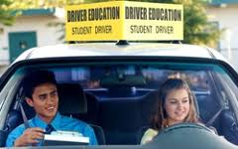
The First Steps Program
The first steps program is designed for nervous students, students who lack confidence and basic driving skills. It is also useful for parents who lack the time or nerves to work with beginning students. The program consist of the basics:
- Starting procedures
- Proper hand & foot movements
- Right away rules
- Speed & directional control
- Lateral movements
- Controlled turns
- Backing
- Securing the vehicle
This is an introductory program consisting of five 45 minute lessons (private/semi private). Current cost is $220.00. These lessons cannot be applied to VA state approved program. No other discounts apply. Availability and pick up area may be limited.

