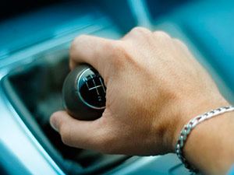

Manual/Stick Shift Training for Teen

We offer manual/stick shift training as a supplement to the regular Behind-The- Wheel program. Each lesson is 45 minutes. The package prices are listed below.

Prices

3 lessons $215

5 lessons $340

7 lessons $470

10 lessons $660

Requirements: The above rates are for Instructor’s Choice student currently enrolled (or former enrolled) students. Students are required to have good control (directional & speed control) of the car. Students must have a good basic knowledge of rules of the road. THIS IS NOT A PROGRAM FOR BEGINNING STUDENTS.